Sentiment Analysis Using Neural Networks

Task 2
Kiara Angelys Gänger
Western Governor University
D213 | Advanced Data Analytics

Scenario
As a data analyst, you will assess continuing data sources for their relevance to specific research questions throughout your career. The two organizations related to the given data set seek to analyze their operations and have collected variables of possible use to support decision-making processes.

Part I: Research Question

Research Question

Question
Can we predict customer sentiment positive or negative based on textual reviews from Amazon, IMDB and Yelp?

Objectives and Goals
The main goal of this analysis is to develop a neural network that can help me predict customer sentiment based on their reviews. Which would demonstrate the model's effectiveness in real-world applications, such as automating customer feedback analysis or enhancing decision-making in customer service strategies. I am hoping to achieve this by meeting the objectives outlined below:
- Combine the Amazon, IMDB and Yelp reviews (Kotzias, 2015)
- Clean and split the dataset
- Classify customer reviews as positive or negative using NLP techniques

Neural Network Type
The neural network used for this analysis is a Recurrent Neural Network (RNN), specifically Long Short-Term Memory (LSTM). RNN, because it handles sequential data like text more effectively. RNN create a system that allows them to remember information from earlier inputs by feeding the output of one step back as input to the next (GeeksforGeeks, Introduction to recurrent neural networks, 2024).
LSTM, because it is better at capturing the memory of sequential information then RNN alone. The only down said is that it is slower to train, but has better accuracy (GeeksforGeeks, Sentiment Analysis with an Recurrent Neural Networks (RNN), 2024).

Part II: Data Preparation

Summarize Data Cleaning Process
Following the providing the Data processing video and PowerPoint slides by Dr. Elleh, I was able to complete the following (Elleh, Data Preprocessing Python Task 2 Panopto Video, 2024), (Elleh, Advanced Data Analytics - Task 2 PPT, 2024):

Data Exploration
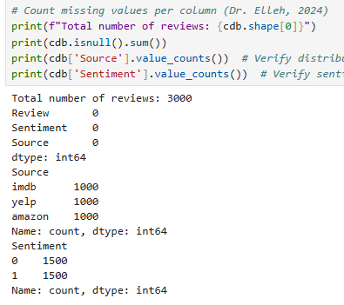
During the exploration of the data, I pulled the shape and distribution of the data set. Here I was able to see that the combined three datasets had a total of 3000 rows and two columns. The Dataset didn’t have a heading, so I added one “Review” for the review column and “Sentiment” for the column with the scores of 0 and 1.I was also able to determine that the Sentiment column had an even split of 0 to .
The check for any Null values returned no missing values and the Initial Word count returned a Unique character count of 88 and Vocab count of 7352. The list I pulled is shown below:
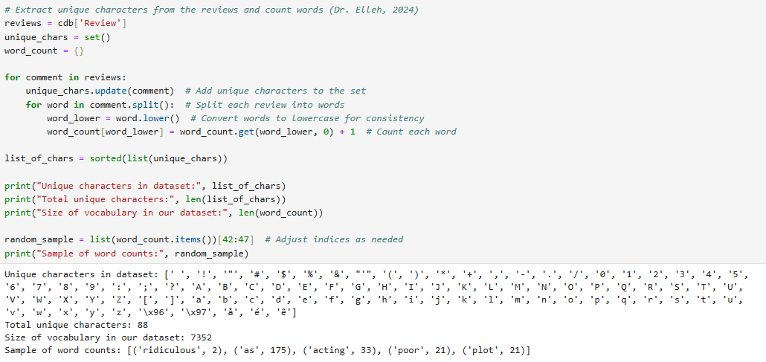
I then converted all letters to lowercase, and added an additional column to allow for the changes to be viewed named “Clean_Review”
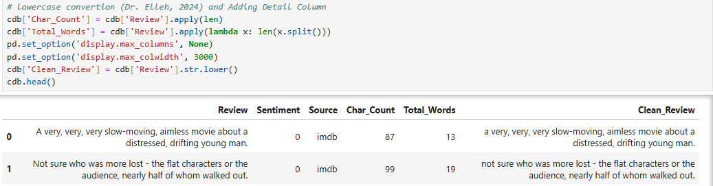
After I got a better understanding of what cdb looked like I was to look for any Presence of unusual characters. This included emojis :-) , punctuation, special characters. I looked for any signs of emojis which are made up of characters and punctuations and other forms of punctions and special characters then removed them which were removed.
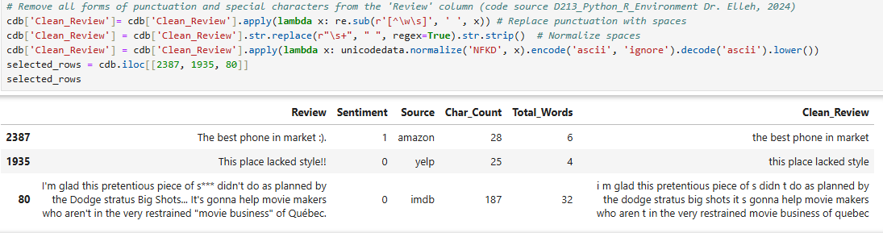
I then preformed Tokenization(explained in full in section B2), which broke down each sentence into “tokens”. Here I was able to preform lemmatization. lemmatization step allows the algorithm to map words at its root. For example runs, running and ran will all become run with lemma (Pykes, 2023). Since it changes words down to it roots it made more sense to do this step before removing any stop word. Which I followed this step with. I removed a certain list of stop words. I withheld a few words from the list to maintain the integrity of the sentiment analysis. I kept words like “no” and “never” since they detect negative sentiment, “but” and “yet” because they add context
After preprocessing, the vocabulary size was reduced to 4,660 unique words, representing the cleaned and tokenized dataset. The final word embedding length was set to 8, representing the vector position of each word in the learned vector space (Elleh, Advanced Data Analytics - Task 2 PPT, 2024). I also found the word and sentence length of the longest of each in the dataset.
Statistical justification for the chosen maximum sequence length
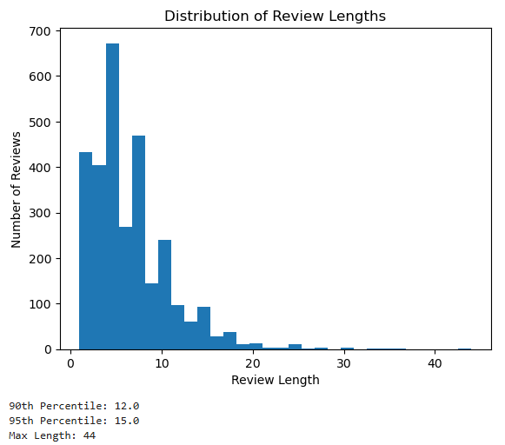
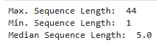
The statistical justification of choosing the max sequence length was to preserve the data available. I used the max length of 9. Looking at the snip it below you can see that the max review is 44, with an avg of 5. Since the 44 seemed to be very far off from 5 I ran a distribution chart to get a visual and verified that the 44 was an outlier and that most of the data had about 12 words per review. So, I used 9 as my max seq len or max review as written in code because its strikes a balance between both the chart and the median.
Figure 6

Tokenization Process
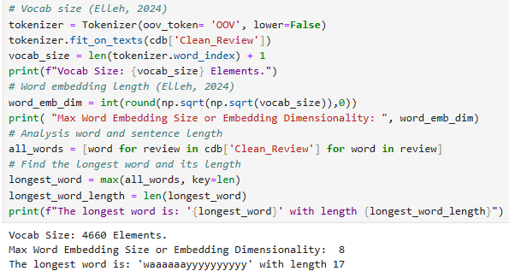
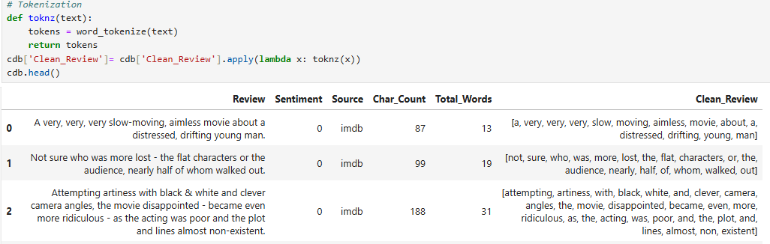
My goal in the tokenization process was to get the words in a format that could be understood by the NN. By tokenizing the text, I was able break down the text into individual words or tokens, which can then be converted into numerical representations for the model. This process was able to be achieved by normalizing the data. In converting all letters to lower case ensured that "Run" and "run" were treated as the same token. Stop words were removed to focus on meaningful words and reduce noise. The tokenization also provides a word index which helps verify that the data is clean enough to move forward. After recounting the tokens, I was also able to get a new Vocab count.

Padding Process

The padding process included finding the distribution of the words per row. I first figured out the min, median and max of the clean reviews. Then plotted a visual. After plotting the chart(above), I was able to determine that I will use the median length
+ 4 for the pad length. In this case it was 9. It is slightly above the median, ensuring we capture more information from the majority of reviews while avoiding the inclusion of extreme outliers. I first dropped the unneeded columns and then split the data. Then I was able to add the padding to each training, testing and validation.
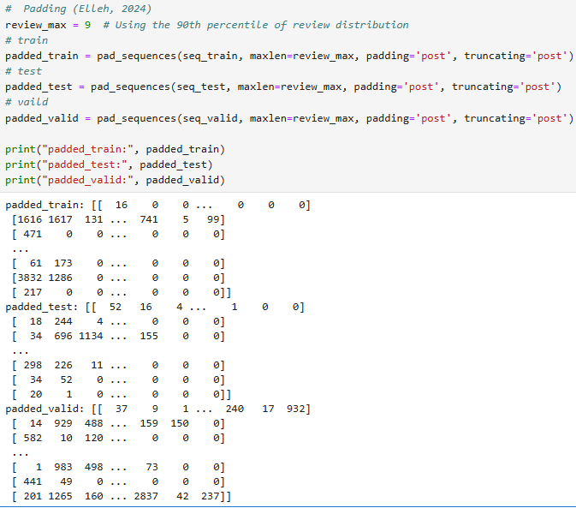

Categories of Sentiment
Since the data is already divided into two categories, I used sigmoid which fits the models needs.

Steps Used to Prepare the Data
The steps I took to prepare the data:
- Imported packages
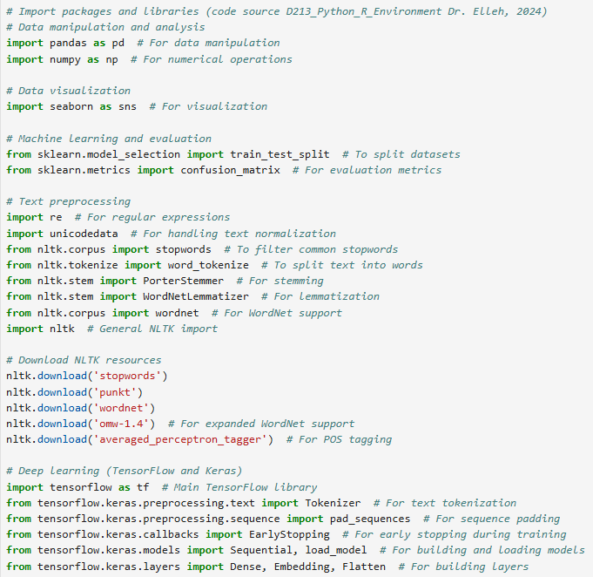
- Data Import
Here I import the data sets and then combine them into one table. Adding a source column to to provide some insight during the cleaning process,
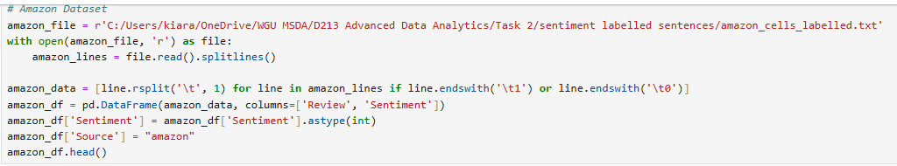
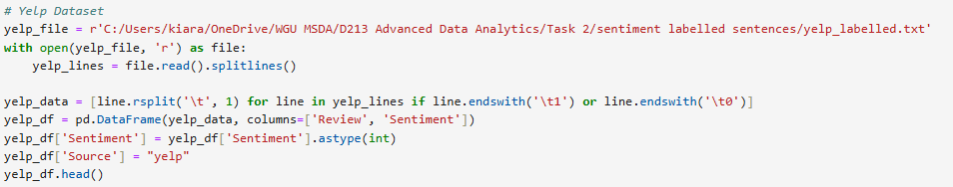
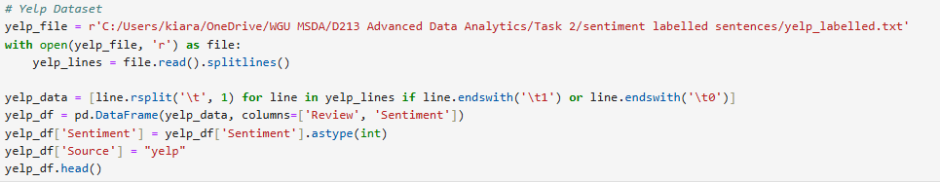
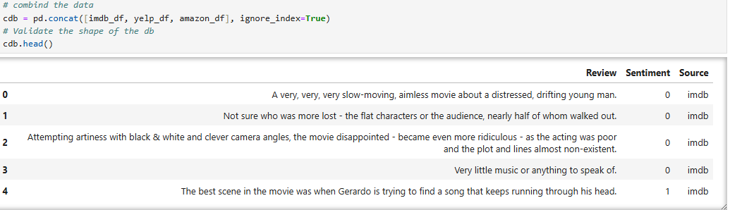
- Data Exploration
In order to clean the data I need to first get the shape and info of the table including if it had any null values:
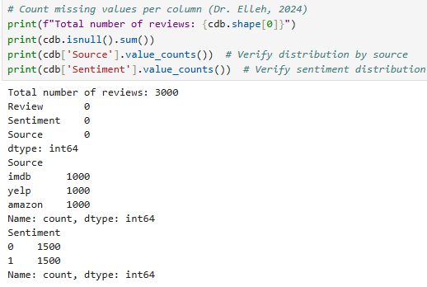
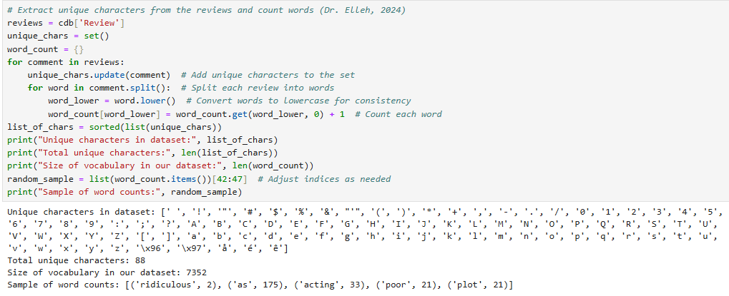
- Data Cleaning
To clean the data I first converted everything to lowercase
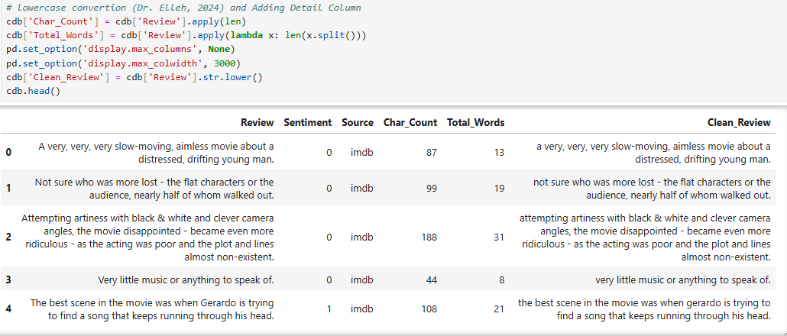
Looked for and removed any signs of emojis, punctuations and special characters
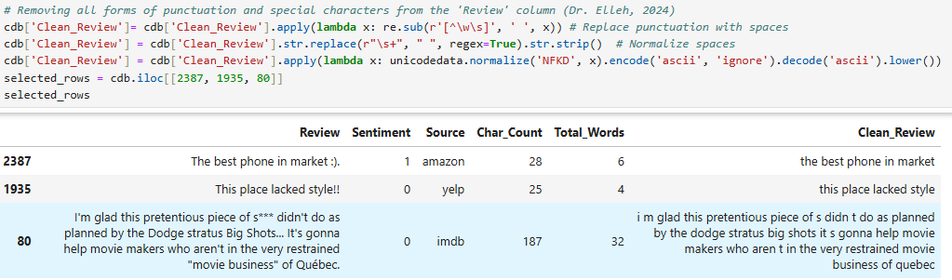
- Tokenizer, Lemmatization and stop words
This step allowed for noise reduction and the tokening of words
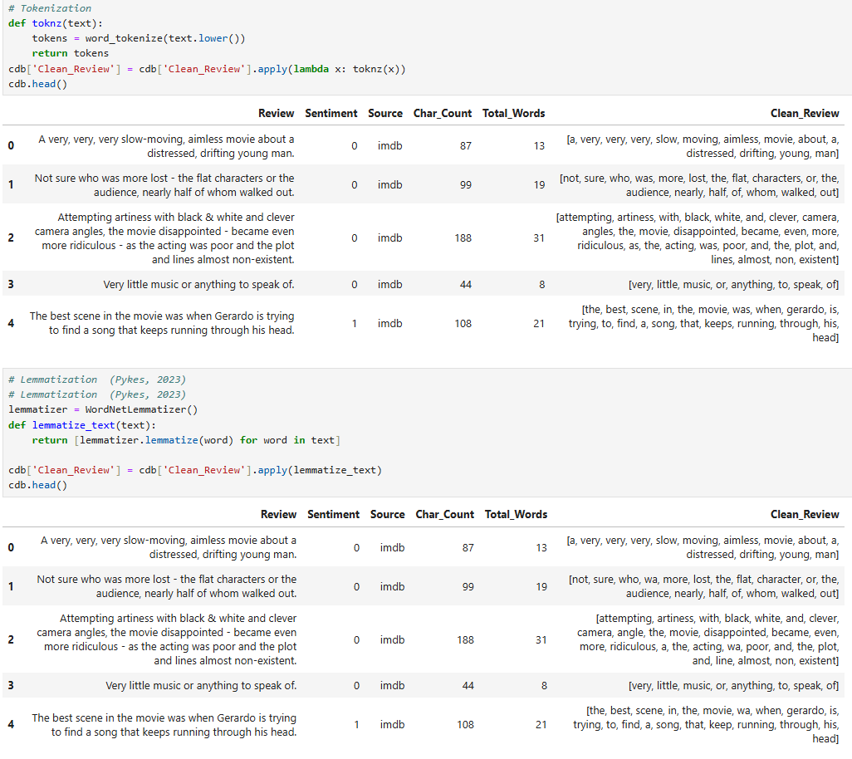
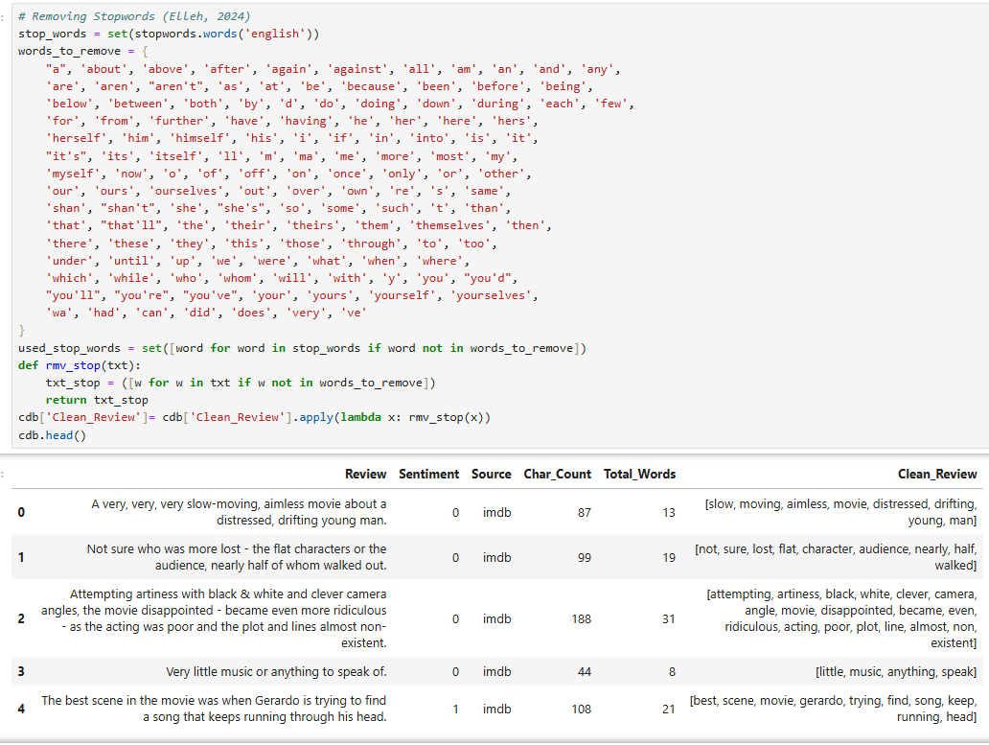
- Determining Review_max for model
I plotted the word disruption count and pulled the max min median. I ended up choose a happy medium between the median and 90th percentile distribution
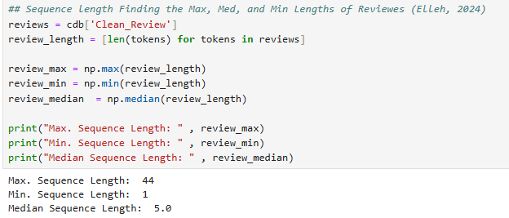
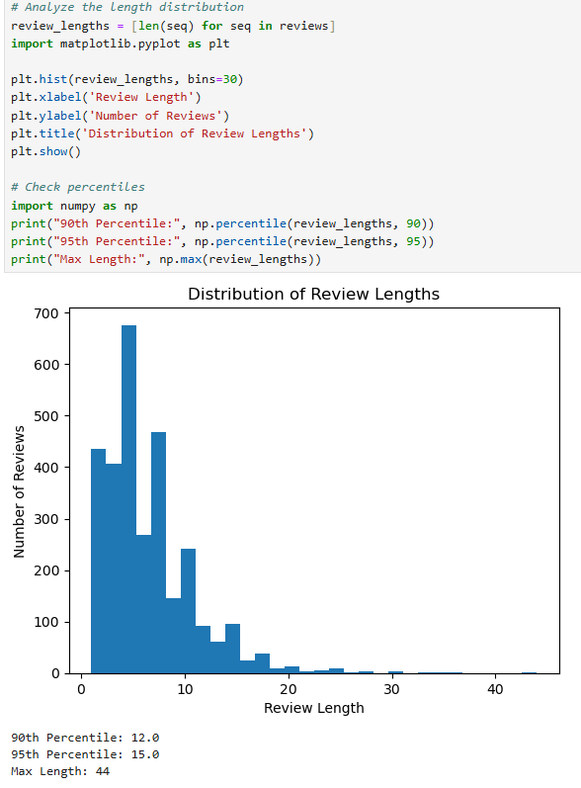
- Word Index
After dropping the unneeded columns and splitting the data, I validated the shape, tokenized and padded the sets.
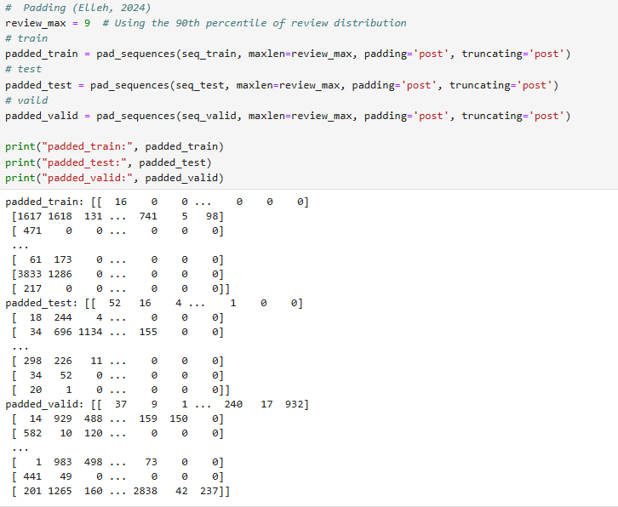
I then pulled the word index for the training dataset
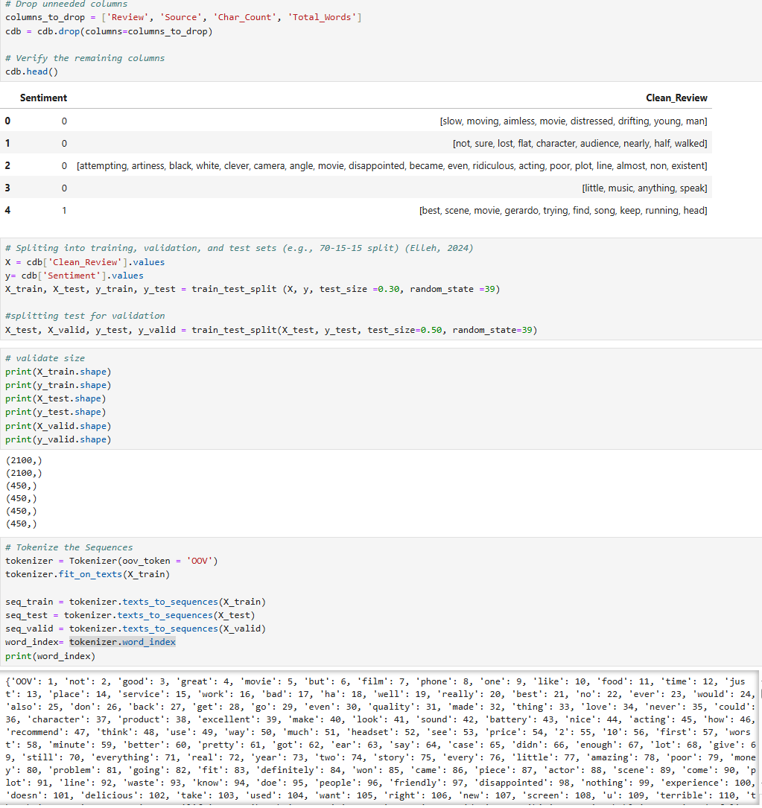
- Model Prep
before my model I verified the distribution of the Sentiments
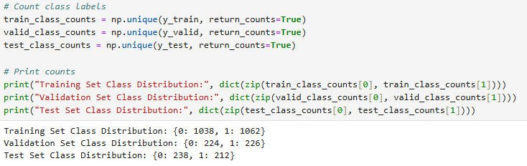
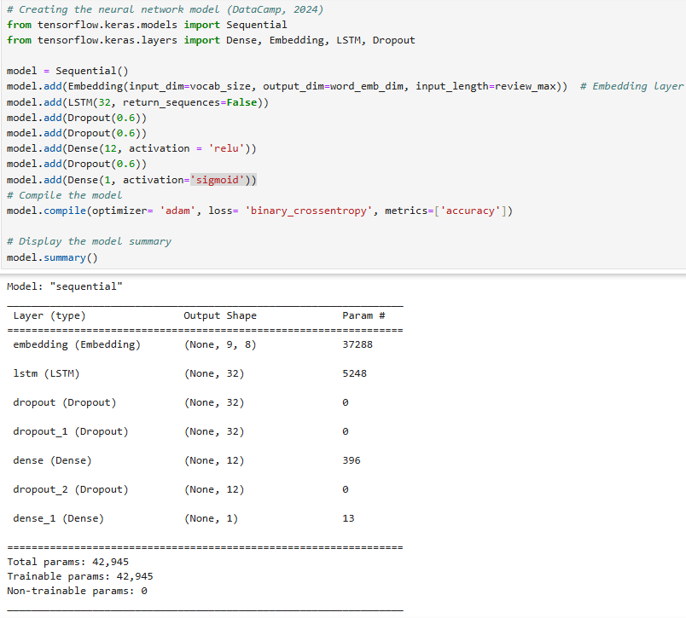

Part III: Network Architecture

Describe the type of network used

Output of the Model Summary


Discussion of Layers, Types, and Parameters
The model consists of 7 layers:
- An embedding layer
- One LSTM layer
- Three Dropout layers
- Two Dense (fully connected) layers
Type of Layers:
- Embedding Layer: Converts text input into dense word vectors of a fixed size (8) (Chen, Mikolov, Corrado, & Dean, 2023).
- LSTM Layer: Captures temporal relationships in the data, critical for sequential data like text.
- Dropout Layers: Helps reduce overfitting by randomly dropping nodes during training.
- Dense Layers: Performs the final classification with one output node for binary classification.
Total Parameters:
- The total number of trainable parameters is 42,945.
- These include weights and biases across all layers.

Justify the choice of hyperparameters
Activation functions
- ReLU (Rectified Linear Unit): Used in the dense layer to add non-linearity and help the network learn complex patterns.
- Sigmoid: Used in the final output layer as it maps the outputs to probabilities between 0 and 1, suitable for binary classification (Bishop, 2006)
Number of nodes per layer
- The LSTM layer has 32 nodes to balance between computational efficiency and the ability to capture temporal dependencies
  - For this one I set it 32 nodes to starts and didn’t make any adjustments
- The first dense layer has 12 nodes, offering a middle ground between complexity and performance
  - I had originally stated with 4 and worked my way up by 2s until I noticed that more then 12 made no difference but less needed improvement.
- The output layer has a single node to represent binary sentiment prediction.
  - This layer I left as is, I thought of it has a control
Loss Function:
- Binary Crossentropy: I picked it because it is well-suited for binary classification tasks by penalizing incorrect predictions based on their distance from the correct probability.
Optimizer
- Adam: I used it for its efficiency and adaptive learning rate capabilities. Due to its iterative nature towards adjusting weights, Adam also has a high level of adaptability and is able to handle noise in the input model well (Otten, 2023)
Stopping Criteria
- EarlyStopping: Monitors the validation loss and stops training if no improvement is observed for 2 consecutive epochs, which helps prevent overfitting. Evaluation Metric:
Evaluation Metric
- Accuracy: Chosen because it provides a straightforward measure of the model’s performance in correctly classifying positive and negative sentiments.

Part IV: Model Evaluation

Evaluation of Model Training and Results

Stopping Criteria
I used an EarlyStopping criterion to monitor the validation loss. This stopping mechanism stoped the training process after two consecutive epochs without improvement in the validation loss. The total number of epochs was set at 20, but the training stopped earlier at the 9th epoch when there was no improvement seen. This helped minimize overfitting and reduced unnecessary computation time.
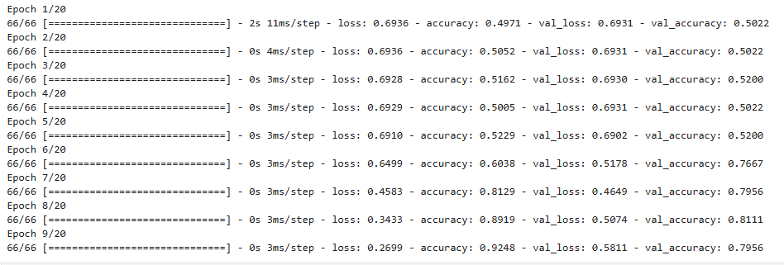

Fitness of the Model and Overfitting
The model's fitness was evaluated by comparing the training and validation. Looking at the training and validation loss graph, the validation loss began to plateau while the training loss continued to decrease. This means the model is generalizing well without overfitting. By adding multiple dropout layer I was able to help deactivate neurons during the training to reduce the risk of overfitting. And by adding the earlystopping I was able to have model stop before overfitting started.

Visualizations
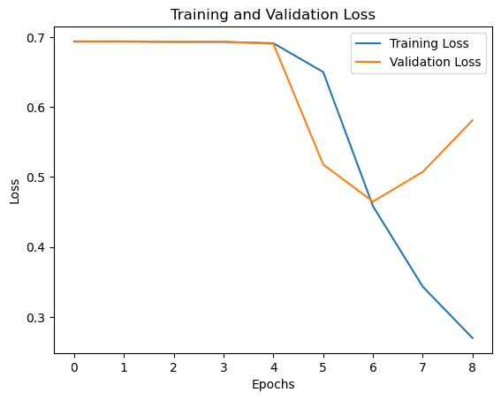
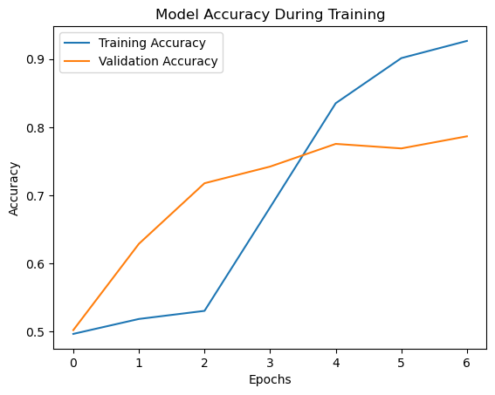
- Training Process Graph (below) shows that after epochs 6 the training decreases, and the validation loss stabilized.
- The accuracy graph above shows the training and validation accuracy over successive epochs during the model's training process. Both show an upward trend pointing to improved training performance.

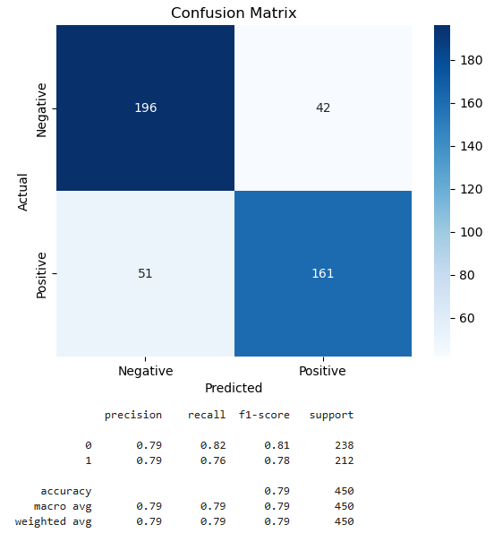
- Confusion Matrix shows the number of true positives, true negatives, false positives and false negatives. The model read 167 positive and 188 negative reviews correctly. With 45 negatives and 50 positives being read wrong.
Giving my model a 79% accuracy.

Part V: Summary and recommendations

Code Used:
Attached to the submission as Task 2.html

Functionality of Neural Network
My neural network was designed to help me answer Can we predict customer sentiment positive or negative based on textual reviews from Amazon, IMDB and Yelp? I make this happen I had to train the dataset with 3000 customer reviews. The Review provided input, and the Sentiments were used as labels to train the network. I validated the model using the unseen data to make sure it could generalize well to new reviews. Tweaking the dropout layers and dense layers I was able to achieve 79%(rounded up) accuracy.
With the accuracy score of 79% I can confidently say that my model met my objective, and its safe to make company recommendations using with keeping those numbers in mind.
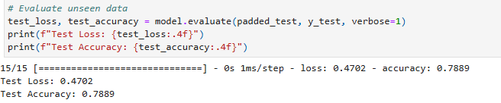

Recommendations
I would recommend collecting more data, which will give us a bigger sample pile to work with. The will allow the model to capture a wider variety of linguistic patterns and sentiments. This could lead to improved accuracy. Another would be running a different version of Lemmatization to remove the ‘ed’ at the end of words. This will help reduce noise further by allowing the system to read walked as walk and not have two token value for the ‘same’ word.

Part VI: Reporting

Jupyter Notebook
attached as Task 2.html

References
Bishop, C. M. (2006, January ). Pattern Recognition and Machine Learning. Retrieved from Springer: https://www.microsoft.com/en-us/research/publication/pattern-recognition-machine-learning/?msockid=3a28c7ca325b6a142246d382330c6b2d
Chen, K., Mikolov, T., Corrado, G., & Dean, J. (2023, January 16). Efficient estimation of word representations in vector space. Retrieved from arXiv.org: https://arxiv.org/abs/1301.3781
Elleh, D. F. (2024, April 29). Advanced Data Analytics - Task 2 PPT. Retrieved from westerngovernorsuniversity.sharepoint: https://westerngovernorsuniversity.sharepoint.com/:p:/r/sites/DataScienceTeam/_layouts/15/Doc.aspx?sourcedoc=%7B50F5B89A-72F1-4964-9942-1F3790EF1D59%7D&file=D213%20Task%202%20Cohort%20Webinar%20PPT.pptx&action=edit&mobileredirect=true
Elleh, D. F. (2024, March). Data Preprocessing Python Task 2 Panopto Video. Retrieved from Panopto: https://wgu.hosted.panopto.com/Panopto/Pages/Viewer.aspx?id=8639374a-964b-4ae9-b33b-b1210052c07d
GeeksforGeeks. (2024, November 19). Activation functions in Neural Networks. Retrieved from GeeksforGeeks: https://www.geeksforgeeks.org/activation-functions-neural-networks/?utm_source=chatgpt.com
GeeksforGeeks. (2024, November 15). Introduction to recurrent neural networks. Retrieved from GeeksforGeeks: https://www.geeksforgeeks.org/introduction-to-recurrent-neural-network/
GeeksforGeeks. (2024, September 11). Sentiment Analysis with an Recurrent Neural Networks (RNN). Retrieved from GeeksforGeeks: https://www.geeksforgeeks.org/sentiment-analysis-with-an-recurrent-neural-networks-rnn/
Kilinc, C. (2021, December 14). Padding for NLP. Retrieved from Medium: https://medium.com/@canerkilinc/padding-for-nlp-7dd8598c916a
Kotzias, D. (2015, May 29). Sentiment Labelled Sentences [Dataset]. doi:10.24432/C57604
Otten, N. V. (2023, March 1). Adam Optimizer Explained & How To Use In Keras, PyTorch & TensorFlow. Retrieved from Medium: https://medium.com/@neri.vvo/adam-optimizer-explained-how-to-use-in-keras-pytorch-tensorflow-322c55ca6bb4
Pykes, K. (2023, Febuary 28). Stemming and Lemmatization in Python. Retrieved from DataCamp: https://www.datacamp.com/tutorial/stemming-lemmatization-python

